# **Project Screen Shots:**

1. Home Page:

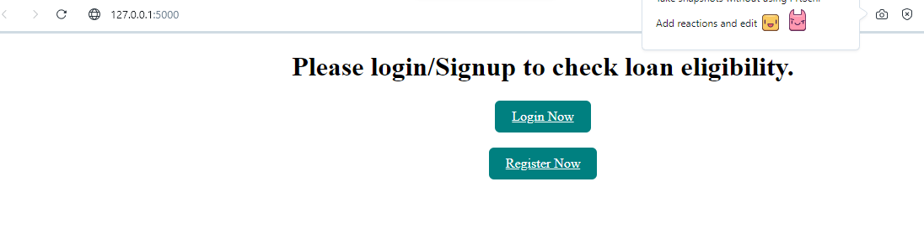

1. Register Page:

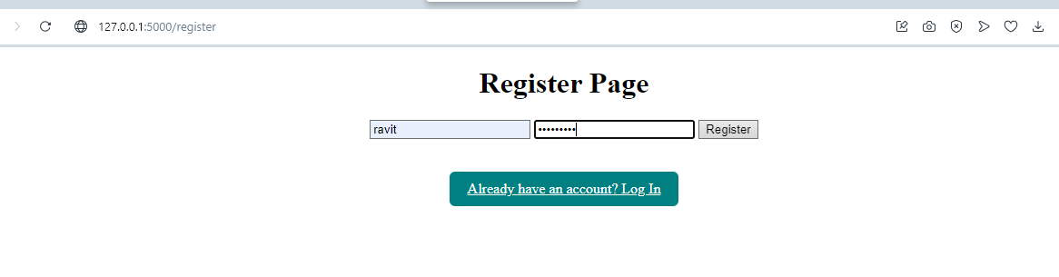

1. Data Store in Mysql

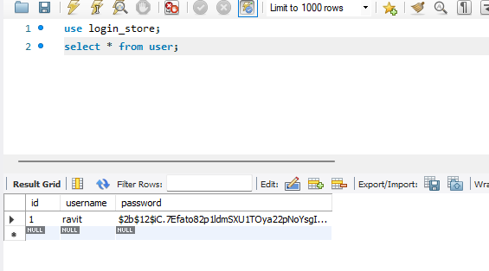

1. Login Page:

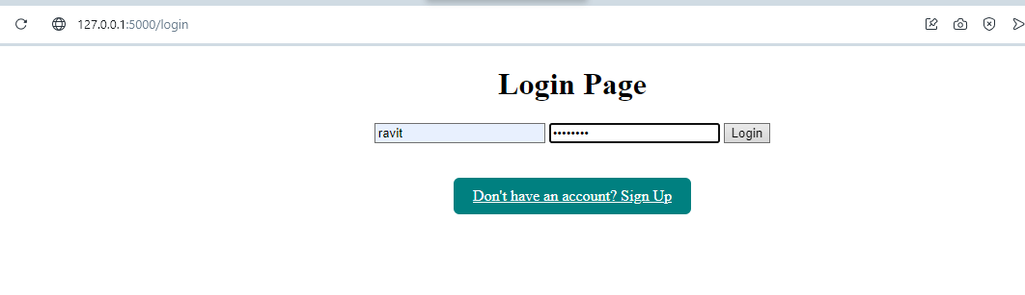

1. Prediction page:

